Correspondence analysis

The analysis was aimed to reveal some general patterns in long-term dynamics  of demographic structure. The first principal axis explaining ++% of total inertia divided all demographic traits into two groups. Total abundance (N) and abundance of juveniles (Age2_3) were in  positive association with CA1 whereas biomass (W), abundance of old mussels (Age4_6, Age7_9, Age10_12) and all growth characteristics (OGP, max_L, size_5) were negatively associated with this principal axis. Thus the increase of CA1 values can be interpreted as a growth  of juvenile abundance which is the reason for the total abundance increasing.

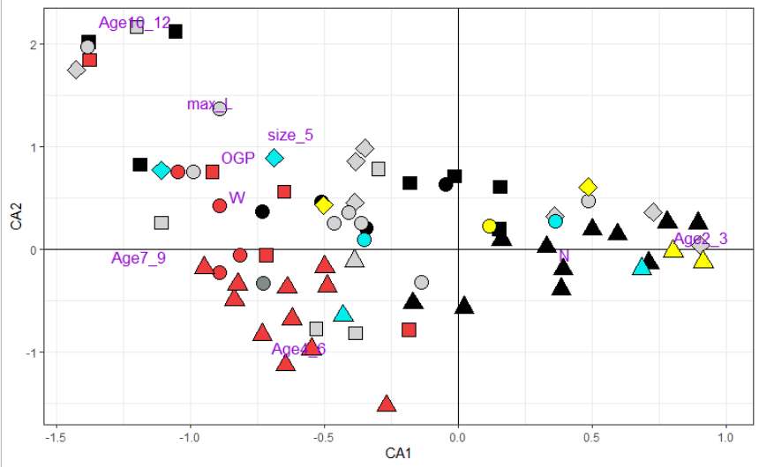

The second principal axis (CA2) explained ++% of total inertia. The abundance of the oldest mussels (Age10_12), total biomass (W) and all characteristics of mussel growth were in positive association with CA2.  The abundance of middle aged mussels (Age4_6) was negatively correlated with CA2. Total abundance (N) and abundance of juveniles (Age2_3) and middle aged group (Age7_9) show no correlation with CA2 having near zero score values. The increase of CA2 can be interpreted as mussel settlement oldering: increase of old mussel abundance with settlement dominated by large mussels.

Ordination of settlements in corresponding axes allowed to reveal some pattern of mussel dynamics. Samples from all habitats (they are coded by different point shapes at Fig ++) being collected in different periods (different color of points at Fig ++) are situated both in positive and negative parts of the CA1 and CA2 axes. It allows for some temporal changes in demographic structure. The more  accurate analysis of changes in CA1 and CA2 scores allowed us to reveal some temporal patterns. The CA1 scores demonstrated a clear increasing pattern in the case of the litoral part of mussel bed and mussel settlements on rocky shores. This tendency was less pronounced in the case of the subtidal part of the mussel bed. These patterns in CA1 changes can be interpreted as transposition from old dominated to young dominated settlements. The reverse tendency was revealed in the case of kelps where CA1 obviously decreased during the observation period.  Thus settlements from this habitat transposed from a young dominated stage to old dominated one. No clear dynamics pattern was revealed  in the case of shoals (probably due to lack of samples from these habitats in the last period of observations). No clear temporal patterns in CA2 scores were revealed (Fig. ++).

